2019 TOM GRAHAM 5th Grade

Conservation Farm Tour

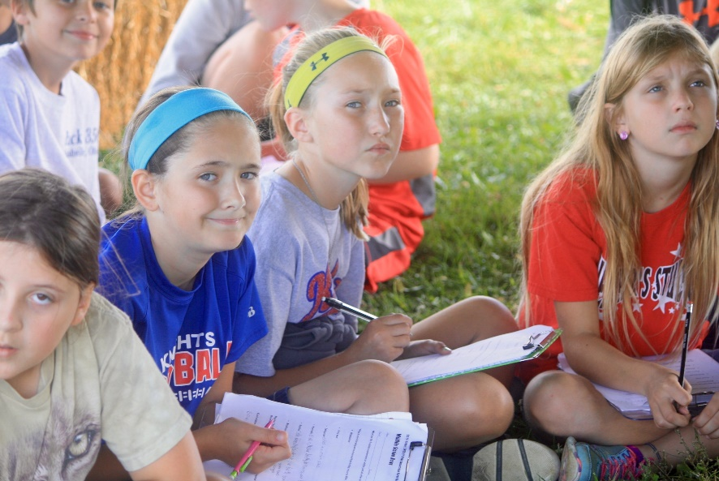

# Hands-On Learning Aligns with Next Generation Standards

Since 1965, Holmes Soil & Water Conservation District has organized a farm tour for Holmes County 5th grade students with topics related to agriculture & natural resources.

The tour is designed to teach students about conservation natural resources and how farmers participate in conservation efforts in Holmes County.

Since farmers typically own a lot of land, they play an important role in the conservation of soil, water, & wildlife. Most people are not aware farmers provide food & habitat for 75% of wildlife nationwide or that 87% forests are privately owned.

In 1992, the tour was renamed the Tom Graham 5th Grade Conservation Farm tour in memory or Tom Graham, a soil scientist who taught 5th graders about soils on the tour for about 12 years before his death.

This year’s tour takes place in two locations: Spring Walk Farm, owned by the Wachtel family of Nashville (hosts of the 2017 tour, and One-O-One Ranch, owned by Tom and Sarah Miller near Walnut Creek, hosts of several previous tours.

The stops on the Tom Graham 5th Grade Conservation

Farm Tour are designed not only to provide students with a working knowledge of modern conservation and it’s importance, but they are also designed to align with the same Next Generation Science Standards being used in today’s classrooms.

### physical Science: Energy

PS3-1: Use models to describe that energy in animals’ food (used for body repair, growth, motion, and to maintain body warmth) was once energy from the sun.

Energy in Chemical Processes & Everyday Life:

* The energy released from food was once energy from the sun that was captured by plants in the chemical process that forms plant matter (from air & water).

Organization of Matter & Energy Flow in Organisms:

* Food provides animals with the materials they need for body repair & growth and the energy they need to maintain body warmth & for motion.

Crosscutting Concepts:

* Energy & Matter: Energy can be transferred in various ways &

between objects.

Relevant tour stops: Farming, Forestry, and Wildlife

### Life Science



Ecosystems: Interactions, Energy & Dynamics

LS2-1: Develop a model to describe the movement of matter among plants, animals, decomposers & the environment.

Interdependent Relationships in Ecosystems:

* The food of almost any animal can be traced back to plants. Organisms are related in food webs in which some animals eat plants for food & other animals eat the animals that eat plants. Some organisms, such as fungi & bacteria break down dead organisms (both plants or plant parts and animals) and therefore operate as “decomposers.” Decomposition eventually returns (recycles) some materials back to the soil. Organisms can survive only in environments in which their particular needs are met. A healthy ecosystem is one in which multiple species of different types are each able to meet their needs in a relatively stable web of life. Newly introduced species can damage the balance of an ecosystem.

Cycles of Matter & Energy Transfer in Ecosystems:

* Matter cycles between the air and soil and among plants, animals, and microbes as these organisms live and die. Organisms obtain gases and water from the environment and release waste matter (gas, liquid, or solid) back into the environment.

Crosscutting Concepts:

* Systems & System Models: A system can be described in terms of its components & their interactions.

Relevant tour stops: Farming, Forestry, Soil, Water Quality & Wildlife

### Life Science

From Molecules to Organisms: Structures & Processes

LS1-1: Support an argument that plants get the materials they needful growth chiefly from the air & water.

Organization of Matter & Energy Flow in Organisms:

* Plants acquire their material for growth chiefly from air & water.

Crosscutting Concepts:

* Energy & Matter: Matter is transported into, out of, & within systems

Relevant tour stops: Forestry & Water Quality

### Earth & Space Science Earth & Human Activity

* ESS3-1: Obtain & combine information about ways individual communities use science ideas to protect the Earth’s resources & environment.

Human Impacts on Earth Systems:

* + Human activities in agriculture, industry, and everyday life have had major effects on the land, vegetation, streams, ocean, air, & even outer space. But individuals and communities are doing things to help protect Earth’s resources & environments.

Crosscutting Concepts:

* + System & System Models: A system can be described in terms of its components & interactions.

Relevant tour stops: Farming, Forestry, Soil, Water Quality & Wildlife

The Holmes Soil & Water Conservation

District assists landowners in applying

conservation practices

that reduce erosion, provide

better

drainage, restore woodland & wildlife habitat, and generally improve water quality. Among other services, the SWCD provides information about soils, writes conservation & nutrient management plans, manages a cover crop program, and designs & oversees construction of conservation practices.

In addition to the 5th grade farm tour, our educational programs include in-class and field-trip presentations, an Arbor Day ceremony, Envirothon sponsorships, camp scholarships, and an educational material lending library.

Holmes SWCD supervisors are

Jason Biltz

Harold Neuenschwander Errick Flinner

Jason Schuch

Jason Shumaker

Supervisors serve three-year terms and are responsible for setting the priorities and policies for the district.

### physical Science



The Wachtel family milks Holstein & Guernsey cows on their farm in addition to growing crops for feed. The Millers raise beef cattle on their farm. Both farms have implemented several conservation practice including cover crops , vegetative filter strips, rotational grazing and heavy use area protection.

Holmes SWCD will once again sponsor an essay contest about the tour, and the Hiland and West Holmes FFA chapters are sponsoring a poster contests about the tour.

Awards for both contests will be presented at the Holmes SWCD annual meeting on Tues. November 20 , 2018.

Approximately 400 students from the East Holmes and West Holmes school districts, as well as Holmesville Elementary, are expected to participate in the tour. Both West Holmes & Hiland FFA chapters provide students to assist with the tour as speakers and group leaders.

Matter & Its interactions

PS1-1: Develop a model to describe that matter is made of particles too small to be seen.

PS1-3: Make observations & measurements to identify materials based on their properties.

PS1-4: Conduct an investigation to determine whether the mixing of 2 or more substances results in new substances. Structure & Properties of Matter:

* + - Matter of any type can be subdivide into particles that are too small to see, but even then the matter still exists & can be detected by other means. The amount (weight) of matter is conserved when it changes form, even in transitions in which it seems to vanish.
    - Measurements of a variety of properties can be used to ID materials.

Chemical Reactions:

* + - When 2 or more substances are mixed, a new substance with different properties may be formed. No matter what reaction or change in properties occurs, the total weight of the substances does not change.

Crosscutting Concepts:

* + - Cause & Effect: Cause & effect relationship are routinely identified, tested & used to explain change.
    - Scale, Proportion & Quantity: Natural objects exist from the very small to the immensely large; Standard units are used to measure & describe physical quantities such as weight, time, temperature & volume.

Relevant tour stop: Soils & Water Quality

### Earth & Space Science Earth’s Systems

ESS2-1: Develop a model using an example to describe the ways the geosphere, biosphere, hydrosphere, and/ or atmosphere interact.

ESS2-2 Describe & graph the amounts & percentages of water & fresh water in various reservoirs to provide evidence about the distribution of water on Earth.

Earth Materials & Systems:

* + - Earth’s major systems are the geosphere (solid & molten rock, soil, and sediments), the hydrosphere (water & ice), the atmosphere (air), and the biosphere (living things, including humans). These systems interact in multiple ways to affect Earth’s surface materials & processes. The ocean supports a variety of ecosystems & organisms, shapes landforms, and influences climate. Winds & clouds in the atmosphere interact with landforms to determine patterns of weather.

The Roles of Water in Earth’s Surface Processes:

* + - Nearly all of Earth’s available water is in the ocean. Most fresh water is in glaciers or underground; only a tiny fraction is in streams, lakes, wetlands, and the atmosphere.

Crosscutting Concepts:

* + - System & System Models: A system can be described in terms of its components & interactions.
    - Scale, Proportion & Quantity: Standard units are used to measure & describe physical quantities such as weight, time, temperature & volume.

Relevant tour stops: Farming, Soil & Water Quality

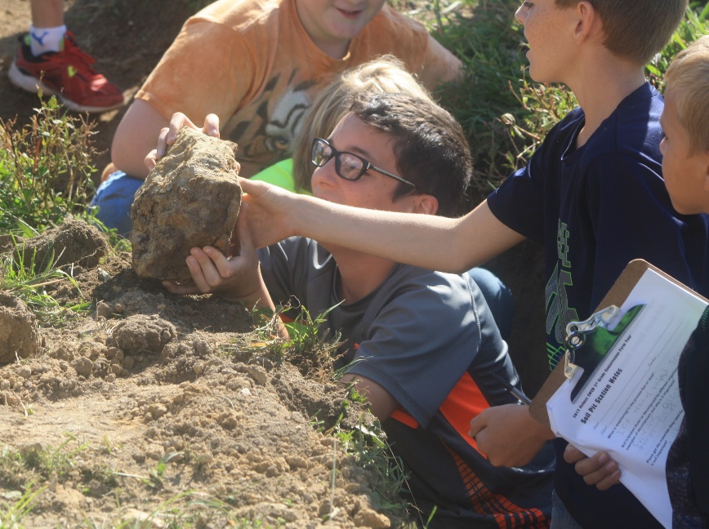

Holmes SWCD is a member of the National Association of Conservation Districts the nonprofit organization that represents America’s 3,000 conservation districts and the 17,000 men and women who serve on their governing boards. Conservation districts are local units of government established under state law to carry out natural resource management programs at the local level. Districts work with millions of cooperating landowners and operators to help them manage and protect land and water resources on all private lands and many public lands in the United States.

Holmes SWCD Staff:

Michelle Wood

Program Administrator

Joe Christner

Water Quality Technician

John Lorson

District Technician

Karen Gotter

Killbuck Creek Watershed Coordinator

Chuck Reynolds

District Conservationist, NRCS

# But wait! There’s more!

There’s no denying that Next Generation Science Standards play a huge role in the content of the Tom Graham 5th Grade Conservation Farm Tour—but the tour is about more than “just science.” This event also aligns with 5th grade learning standards in both social studies & language arts as well. From mapping agricultural land to composing essays about their experience, participants in the farm tour are engaged in numerous cross- curricular learning opportunities.

## Social Studies

### geography Strand Spatial thinking & skills

Globes & other geographic tools can be used to gather, process & report information about people, places & environments. Cartographers decide which information to include in maps.

Relevant tour stops: Water Quality

Latitude & longitude can be used to make observations about location & generalizations about climate.

Relevant tour stops: Forestry & Water Quality Relevant contest: Digital Poster, Traditional Poster

### Economic Strand

economic decision making & Skills Information displayed in circle graphs can be used to show relative proportions of segments of data to an entire body of data.

Relevant tour stops: Soils

Relevant contest: Digital Poster, Traditional Poster



Farm Tour Dates to Know:

Tues.Sept.24, 2019 Holmes SWCD Tom Graham 5th Grade Conservation Farm Tour (east) at Harold’s Equipment near Trail

(rain date Wed. Sept 25)

Thurs. Sept.26, 2019 Holmes SWCD Tom Graham 5th Grade Conservation Farm Tour (west) at Spring Walk Farm, just north of Nashville

(rain date Friday, Sept 27)

October 30, 2019: Deadline for Essay Submission to Holmes SWCD office

Nov. 1, 2019: Deadline for Poster Contest Submissions

November 19, 2019: Holmes SWCD Annual Meeting, 7 p.m., at Carlisle Inn in Walnut Creek.

### History Strand

historical thinking & skills Multiple-tier timelines can be used to show relationships among events & places.

Relevant contest: Digital Poster, Traditional Poster

Relevant tour stops: Forestry & Wildlife

### geography Strand Places & Regions

Regions can be determined using various criteria (e.g. landform, climate, population, cultural or economic) Relevant tour stops: Forestry, Soils, Water Quality, & Wildlife

### geography Strand human systems

Variations among physical environments within the Western Hemisphere influence human activities.

Human activities also alter the physical environment.

Relevant tour stops: Farming, Forestry, Soils, Water Quality, & Wildlife Political, environmental, social, & economic factors cause people, products & ideas to move from place to place in the Western Hemisphere today.

Relevant tour stops: Farming, Forestry, & Water Quality

### Economic Strand Scarcity

The availability of productive resources (i.e., human resources, capital goods & natural resources) promotes specialization that leads to trade.

Relevant tour stops: Farming, Forestry, Soils & Water Quality

### economic Strand Production & consumption

The availability of productive resources & the division of labor impact productive capacity. Relevant tour stops: Farming, Forestry, Soils, & Water Quality

### Economic Strand markets

Regions & countries become interdependent when they specialize in what they produce best & then trade with other regions to increase the amount & variety of goods & services available.

Relevant tour stops: Farming, Forestry, & Water Quality



Visual arts Standards:

Producing/ Performing

* Integrate observational & technical skills to strengthen art making.
* Use digital tools to explore ideas, create & refine works of art during the art making process.
* Experiment with various ideas & visual art media to solve a problem that addresses a contemporary social issue.
* Select & use the principles of art & design to communicate understanding of an interdisciplinary concept.

Relevant contest: Traditional poster & Digital poster

## Language arts

### Writing standards Text Types & Purposes

Write informative/explanatory texts to examine a topic & convey ideas & information clearly

* Introduce a topic clearly, provide a general observation & focus, & group related information logically; include formatting (e.g., headings), illustrations, & multimedia when useful to aiding comprehension.
* Develop the topic with facts, definitions, concrete details, quotations, or other information & examples related to the topic.
* Link ideas with & across categories of information using

words, phrases, & clauses (e.g., in contrast, especially).

* Use precise language & domain specific vocabulary to inform about or explain the topic.
* Provide a concluding statement or section related to the information or explanation presented.

Relevant contest: Informative Essay

Write narratives to develop real or imagined experiences or events using effective technique, descriptive details & clear event sequences.

* Orient the reader by establishing a situation & introducing a narrator and/or characters; organize an event sequence

that unfolds naturally.

* Use narrative techniques, such as dialogue, description, & pacing to develop experiences & events or show the responses of characters to unique situations.
* Use a variety of transitional words, phrases, & clauses to manage the sequence of events.
* Use concrete words & phrases & sensory details to convey

the experiences & events precisely.

* Provide a consolation that follows from the narrates experiences or events.

Relevant contest: Narrative Essay

### Writing standards

Research to build & present knowledge

Recall relevant information from experiences or gather relevant information from print & digital sources; summarize or paraphrase information in notes & finished work, & provide a list of sources. Relevant contest: Informative Essay, Narrative Essay



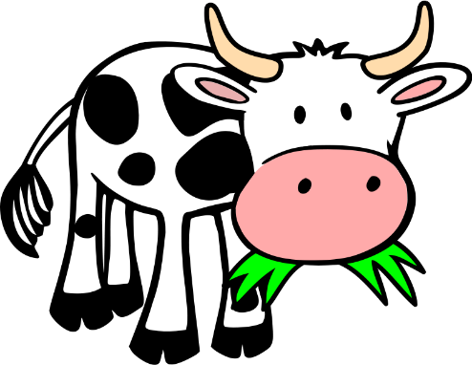

Technology Benchmarks

Productivity applications:

* Use appropriate tools & technology resources to complete tasks & solve problems.
* Use productivity tools to produce create works & prepare publications

Communication applications:

* Develop, publish, & present information in print & digital formats.

Relevant contest: Traditional poster or Digital poster

### Writing standards Production & Distribution of Writing

Produce clear & coherent writing in which the development & organization are appropriate to task, purpose, & audience.

With guidance & support from peers & adults, develop & strengthen writing as needed by planning, revising, editing, rewriting, or trying a new

approach.

With some guidance & support from adults, use technology, including the Internet, to produce & publish writing as well as to interact & collaborate with others; demonstrate sufficient command of keyboarding skills to type a minimum of 2 pages in a single sitting.

Relevant contest: Informative Essay, Narrative Essay Holmes SWCD will also offer an online publishing opportunity.

### Writing standards Range of Writing

Write routinely over extended time frames (time for research, reflection, & revision) & shorter time frames (in a single sitting or day or 2) for a range of discipline-specific tasks, purposes & audiences.

Relevant contest: Informative Essay, Narrative Essay

Speaking & Listening standards comprehension & collaboration Engage effectively in a range of collaborative discussions (1 on 1, in groups, & teacher-led) with diverse partners on grade 5 topics & texts, building on others’ ideas & expressing their own clearly.

* + Follow agreed-upon rules for discussions & carry out assigned roles.
  + Pose & respond to specific questions by making comments that contribute to the discussion & elaborate on the remarks of others.
  + Review the key ideas expressed & draw conclusions in light of information & knowledge gained from the discussions.

Summarize the points a speaker makes & explain how each claim is supported by reasons & evidence. Relevant tour stops: Farming, Forestry, Soil, Water Quality & Wildlife

Relevant contest: Informative Essay, Narrative Essay, Traditional Poster, Digital Poster

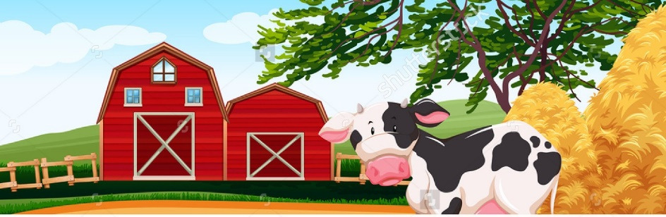

2019

Creative Nonfiction Essay Contest

Creative nonfiction conveys facts in a way that reads like fiction. What we’re looking for are essays built around any number of facts or details that the student has gleaned from his or her experience during their day on the farm woven into a creative delivery. Check HolmesSWCD.com for guidelines and examples.

Poster Contests

NOTE: Rules vary slightly for east and west entries.

Hiland FFA Chapter Contest: Posters must feature student’s original slogan and original artwork and must be traditional, hand drawn and colored.

West Holmes FFA Chapter Contest: Posters must feature student’s original slogan and original artwork and may be traditional, hand drawn and colored OR computer generated.

Full details are available at HolmesSWCD.com

Language standards Conventions of standard english Demonstrate command of the conventions of

standard English grammar & usage when writing or speaking.

* Use verb tense to convey various times, sequences, states,

& conditions.

* Recognize & correct inappropriate shifts in verb tense.
* Use correlative conjunctions (e.g., either/or, neither/nor). Demonstrate command of the conventions of standard English capitalization, punctuation, & spelling when writing.
* Use punctuation to separate items in a series
* Use a comma to separate and introductory element from the rest of the sentence.
* Use a comma to set off the words yes & no (e.g., Yes, thank you), to set off a tag question from the rest of the sentence (e.g., It’s true, isn’t it?), & to indicate direct address (e.g., Is that you, Steve?)
* Spell grade-appropriate words correctly, consulting references as needed.

Relevant contest: Informative Essay, Narrative Essay, Traditional Poster, Digital Poster

### Language standards Knowledge of language

Use knowledge of language & its conventions when writing, speaking, reading or listening.

* Expand, combine, & reduce sentences for meaning, reader/ listener interest, and style.

Relevant contest: Informative Essay & Narrative Essay

### Language standards vocabulary acquisition & use

Acquire & use accurately grade-appropriate general academic & domain specific words & phrases, including those that signal contrast, addition, & other logical relationships (e.g., however, although, nevertheless, similarly, moreover, in addition).

* Expand, combine, & reduce sentences for meaning, reader/ listener interest, and style.

Relevant contest: Informative Essay & Narrative Essay